DevOps Kata

**Bug tracking / work item management**

Last updated: 10/24/2016



1. **TABLE OF CONTENT**

Overview 3

Prerequisites 3

Exercises 3

Exercise 1: Create Work Items 4

Task 1: Create work items 4

Exercise 2: Create a query 5

Task 1: Create a query 6

Exercise 3: Create a bug and test with the test app 8

Task 1: Install the test and explore extension 9

Task 2: Set up for connected mode 9

Task 3: Connect to VSTS 10

Task 4: Create a bug 12

Task 5: Create a test case 17

## Overview

Agile tools provide you with the power, flexibility, and responsiveness you need to stay on top of changing priorities, deadlines, and requirements

### Prerequisites

1. In order to complete the lab
2. 1. Log on to your Visual Studio / MSDN subscription and create a VSTS instance. Alternatively, you can use a team sandbox VSTS instance if you have one.
3. 2. Install the test and feedback explorer from the marketplace: <https://marketplace.visualstudio.com/items?itemName=ms.vss-exploratorytesting-web>

### Exercises

* 1. This hands-on lab includes the following exercises:
  2. Create work item
  3. Create Query
  4. Create bug and test
  5. Homework: Create a query for your bug or test and add a tile to VSTS
  6. Estimated time to complete this exersize: **15 minutes**.

## Exercise 1: Create Work Items

You add work items to plan and manage your project. You use different types of work items to track different types of work - such as tasks, features or user stories, test cases and bugs, risks or issues, and more. You can describe the work to be done, assign work, track status, and coordinate efforts within your team.

Different types of work items are used to track features, user experiences, code defects, tasks, and issues. You can link work items to one another, as well as to changesets and source code files. As the following image shows, each work item form comes with a number of controls, fields, and tabs.

#### Task 1: Create work items

1. From a web browser, connect to the team project that you want to work in. For example, the Fabrikam, Inc. team navigates to http://fabrikamprime:8080/tfs/DefaultCollection/Fabrikam%20Fiber%20Website/.  
   If you haven’t been added as a team member, [get added now](https://www.visualstudio.com/en-us/docs/work/scale/multiple-teams#add-team-members).

From the [New work item widget](https://www.visualstudio.com/en-us/docs/report/widget-catalog#new-work-item-widget) added to a [team dashboard](https://www.visualstudio.com/en-us/docs/report/dashboards), you can choose the type of work item you want to create.

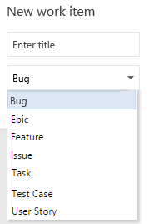

Work items you add are automatically scoped to your [team's area and iteration paths](https://www.visualstudio.com/en-us/docs/work/scale/set-team-defaults). Go [here](https://www.visualstudio.com/en-us/docs/work/backlogs/add-work-items#team-context) to change the team context.

1. Enter a title and then save the work item. Before you can change the State from its initial default, you must save it. 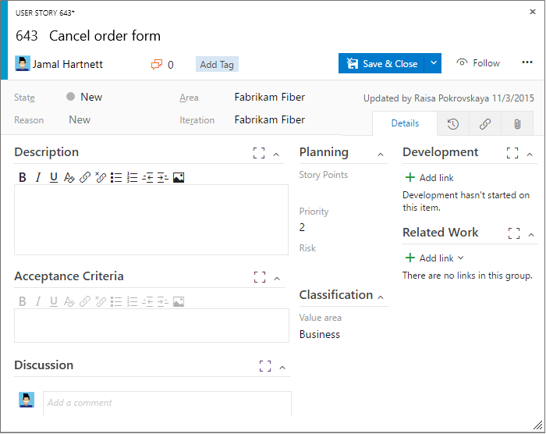

You can [add tags to any work item to filter backlogs and queries](https://www.visualstudio.com/en-us/docs/work/track/add-tags-to-work-items).

1. Repeat the above process for 4 work items

## Exercise 2: Create a query

Queries help you find work items that you want to review, triage, update, or list in a report.

To quickly find a work item by ID, simply enter the ID in the work item search box. Enter a keyword to list items containing the keyword in its title, description, or history.

Otherwise, you can use the Query Editor to craft simple or more complex queries based on the filter clauses you specify. Start by choosing from these three query types:

* [Flat list of work items](https://www.visualstudio.com/en-us/docs/work/track/using-queries#flat-list-query)
* [Hierarchical list using a tree query](https://www.visualstudio.com/en-us/docs/work/track/using-queries#tree-query)
* [List showing dependencies using a direct links query](https://www.visualstudio.com/en-us/docs/work/track/using-queries#directs-link-query)

You can create queries in Team Services, the web portal for Team Foundation Server (TFS), and Team Explorer. Also, you can open a query in [Excel](https://www.visualstudio.com/en-us/docs/work/office/bulk-add-modify-work-items-excel) or [Project](https://www.visualstudio.com/en-us/docs/work/office/create-your-backlog-tasks-using-project) to perform bulk additions and modifications.

#### Task 1: Create a query

You can start a fresh, new query from the Queries page in the web portal or the Work Items page in Team Explorer.

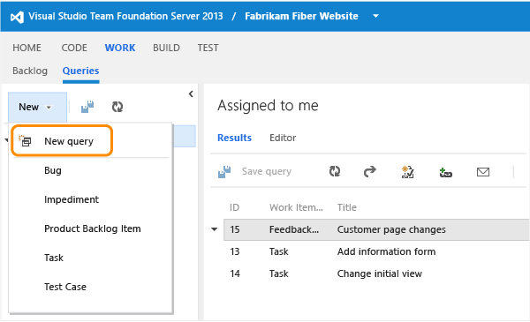

**Group clauses**

Grouped clauses operate as a single unit separate from the rest of the query, similar to putting parentheses around a mathematical equation or logic expression. The And or Or operator for the first clause in the group applies to the whole group.

In the next example, the first expression returns all work items that are priority 1 and all active bugs of any priority. The second expression returns all active priority 1 work items and all priority 1 bugs, whether they are active or not.

For a list of sample queries, go here: <https://www.visualstudio.com/en-us/docs/work/track/example-queries>

|  |
| --- |
| Grouped clauses  Filter Using an OR/AND Operator  Logical expression  Priority = 1 OR (Work Item Type=Bug AND State=Active) |
| Grouped clauses  Filter Using an AND/OR OR Operator  Logical expression  Priority = 1 AND (Work Item Type=Bug OR State=Active) |
| **Grouped clauses** | | **Logical expression** |
| Filter Using an OR/AND Operator | | Priority = 1 OR (Work Item Type=Bug AND State=Active) |
| Filter Using an AND/OR OR Operator | | Priority = 1 AND (Work Item Type=Bug OR State=Active) |

To group one or more clauses, select them and then choose the Group Query Clause icongroup clauses icon.

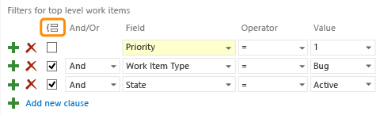

If your query results do not return your expected set of work items, follow these steps:

* Make sure that each clause is defined as you intended.
* Verify And/Or assignments to each clause. If your results contain more work items than expected, often an Or clause is present instead of an And clause.
* Determine if you need to group or change the grouping of the query clauses and the And/Or assignments of each grouped clause.
* Add more query clauses to refine your query filter criteria.
* Review the options available to specify [fields, operators, and values](https://www.visualstudio.com/en-us/docs/work/track/query-operators-variables).

## Exercise 3: Create a bug and test with the test app

1. The **Test & Feedback extension** (previously called the Exploratory Testing extension) helps teams perform exploratory testing and provide feedback. Everyone in the team, such as developers, product owners, managers, UX or UI engineers, marketing teams, early adopters, and other stakeholders can use the extension to submit bugs or provide feedback and contribute to the quality of your product.

**What is the Test & Feedback extension?**

1. The Test & Feedback extension is a simple browser-based extension you can use to test web apps anytime and anywhere, and is simple enough for everyone in the team to use. It helps to improve productivity by allowing you to spend more time finding issues, and less time filing them.
2. Using the extension is a simple, three step process.
3. 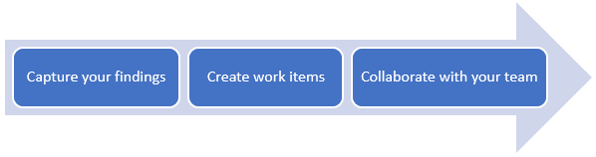

* **Capture your findings** quickly and easily using the tools in the extension. Capture notes, screenshots with annotations, and screen recordings to describe your findings and highlight issues. Additionally, in the background the extension automatically captures rich data such as user actions as an image action log, page load data, and system information about the browser, operating system, memory, and more that can serve as a starting point for debugging.
* **Create work items** such as bugs, tasks, and test cases directly from the extension. The captured findings automatically become a part of the work item. Users can file a bug to report an issue with the product, or create a task that indicates a new work requirement. The extension can also be used to create test cases for scenarios discovered during exploration.
* **Collaborate with your team** by sharing your findings. Export your session report in Standalone mode, or connect to Team Services or Team Foundation Server (2015 or later) for a fully integrated experience including exploring user stories and backlog items, simplified tracking and triaging of bugs and tasks, and managing feedback requests in one place.

1. As users perform exploratory testing, you can [get insights from the sessions](https://www.visualstudio.com/en-us/docs/test/manual-exploratory-testing/insights-exploratory-testing) in the **Test** hub of Team Services or TFS. View completed exploratory sessions and derive meaningful insights across all the sessions. Get end-to-end traceability such as a breakdown of the work items created, the work items explored and not explored, session owners, and more.

#### Task 1: Install the test and explore extension

Go to [Visual Studio Marketplace > Test & Feedback](https://marketplace.visualstudio.com/items?itemName=ms.vss-exploratorytesting-web) and install the extension.

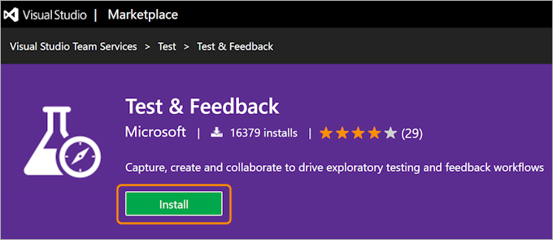

#### Task 2: Set up for connected mode

**Select an exploratory testing mode**

1. Go to Chrome and open the extension.
2. Open extension
3. Decide if you want to use the extension in Connected or Standalone mode.
4. 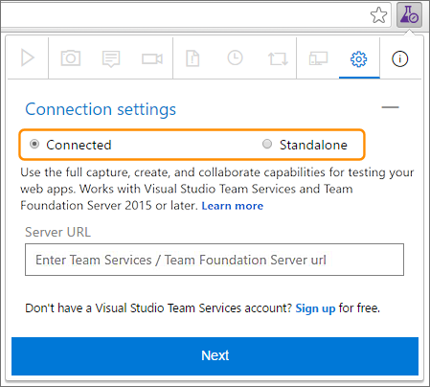
5. [**Connected mode**](https://www.visualstudio.com/en-us/docs/test/manual-exploratory-testing/connected-mode-exploratory-testing)  
   Available to all users of Team Services and TFS 2015 or later:
   * Users with **Basic** access: Full capture and create capabilities to submit bugs, tasks, and test cases. Includes collaboration capabilities such as end-to-end traceability, rich insights across completed exploratory sessions, simplified tracking and triaging for bugs and tasks, and more.
   * Users with **Stakeholder** access: Full capture and create capabilities, except for test cases, to submit feedback and respond to feedback requests from the team.
   * Feedback experience is available only in Team Services and TFS "15" or later.

#### Task 3: Connect to VSTS

1. Open the extension in your web browser and select **Connected** mode.

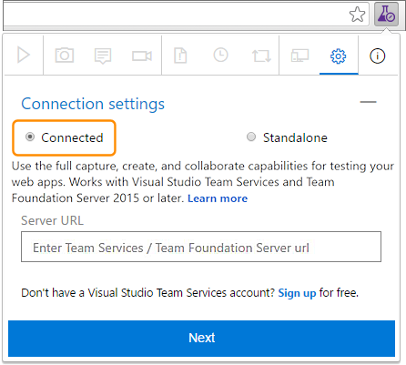

1. Enter the URL of the Team Services account or TFS you want to connect to and choose **Next**.

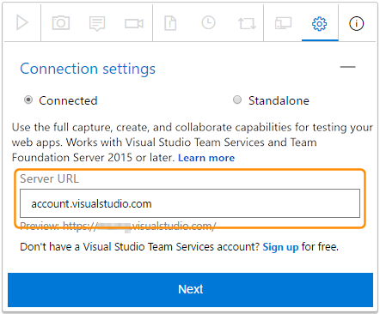

If you are connecting for the first time, you may be prompted to sign in.

1. After connecting to the server, the extension shows all the collections, projects and teams in that server. Select the project or team you want to connect to and choose **Save**.

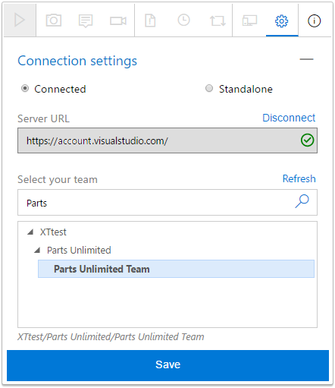

If there are many projects or teams, use the search textbox to find the one you need.

The extension is now ready to be used in **Connected** mode. Depending on your access level (Basic or Stakeholder) you will see the appropriate UI for either [exploratory testing](https://www.visualstudio.com/en-us/docs/test/manual-exploratory-testing/connected-mode-exploratory-testing#create-bugs) or [providing feedback](https://www.visualstudio.com/en-us/docs/test/manual-exploratory-testing/stakeholder/provide-stakeholder-feedback#provide). The extension remembers your selection and remains connected until the session cookies expire or you explicitly disconnect from the server.

#### Task 4: Create a bug

After you have connected, you are ready to begin testing your app.

1. Start your exploratory testing session.

Start your exploratory testing session

1. Open the web application you want to test, and start exploring it.
2. When you find an area that has a bug, take a screenshot of any part of the screen, make notes, or record your actions as a video.

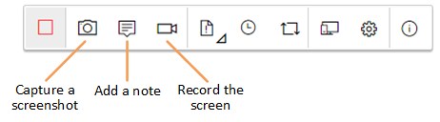

1. When you are done exploring and capturing information, create a bug or a task.

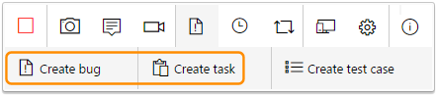

1. The bug or task form contains all your captured information. It also contains an image action log describing your interactions with the page (such as mouse clicks, keyboard typing events, touch gestures, and more) and page load data. Uncheck these options if you do not want to include this data in the bug or task.

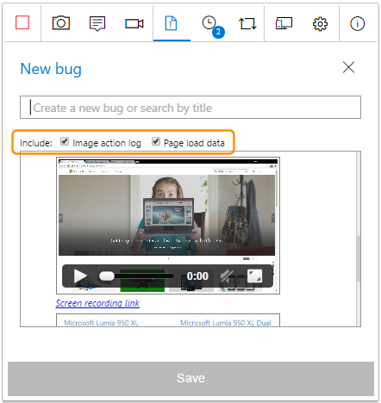

The image action log is the sequence of steps you took that led to the issue. It can be used to reproduce the issue and understand the context. Page load data provides preliminary information about the time it takes to load the pages, such as the resource timings and navigation timelines.

1. Enter a title for the bug or task and add any additional notes you require to the description. Then save the bug or task.

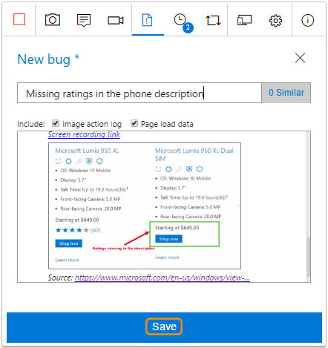

You can also [add your findings to an existing similar bug](https://www.visualstudio.com/en-us/docs/test/manual-exploratory-testing/connected-mode-exploratory-testing#addsimilar).

1. View a list of all your activities in reverse chronological order in the **Session timeline** page. It shows all the screenshots, videos, and notes you've captured, the work items such as bugs, tasks, and test cases you've already filed, and the work items you've explored.

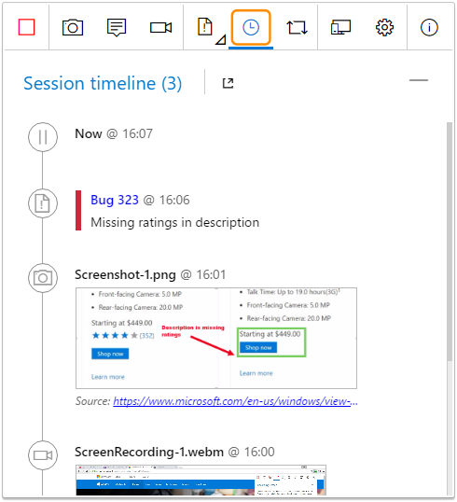

You can use the extension to [explore work items](https://www.visualstudio.com/en-us/docs/test/manual-exploratory-testing/explore-workitems-exploratory-testing) in Team Services or TFS.

1. To view a bug or task in Team Services or TFS, choose the link in the session timeline.

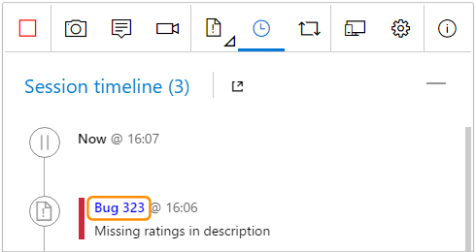

This opens the work item form in Team Services or TFS.

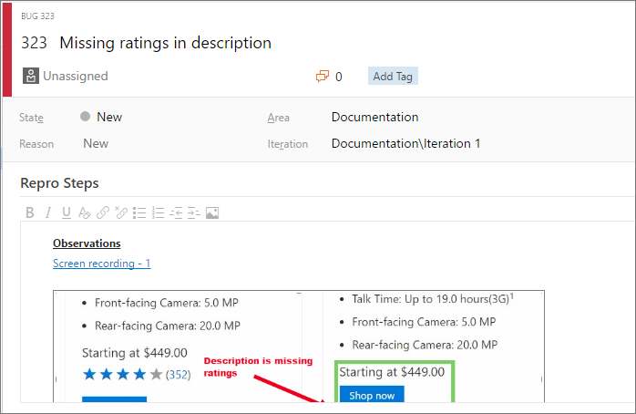

#### Task 5: Create a test case

1. The extension lets you create test cases as you explore your application.
2. When you find a scenario where you want to create a test case, choose **Create test case**.
3. 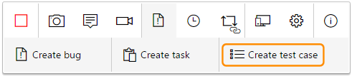
4. The test case form contains a list of all your actions up to this point while exploring the app (it reads them from the image action log).
5. 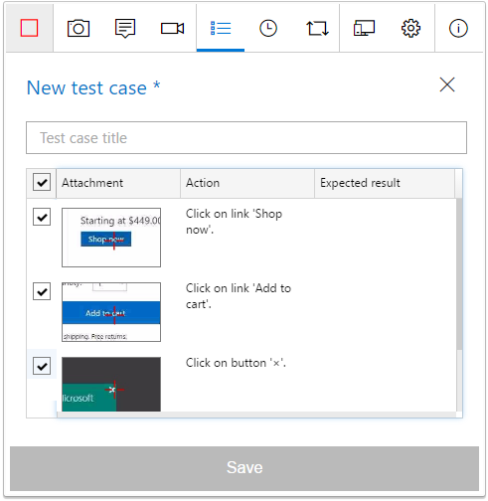
6. Enter a title for the test case and then edit it as required. For example, uncheck the action steps you don't want to include in the test case, edit the captured text, and add the expected result. Then save the test case.
7. 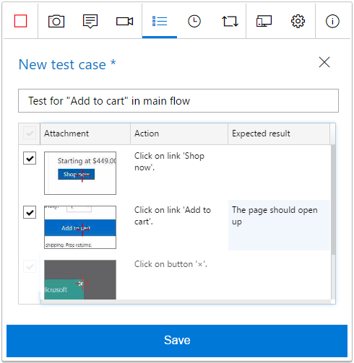
8. Continue exploring the application. Create more bugs, tasks, or test cases as required.

**End your testing session**

1. When you're done, stop your session.
2. Stop the exploratory testing session
3. Open the **Session timeline** page and choose the "view" icon to see your completed exploratory sessions in Team Services or TFS.
4. 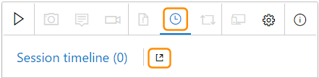
5. Or open the **Recent exploratory sessions** list in the **Runs** tab of the Test hub.
6. 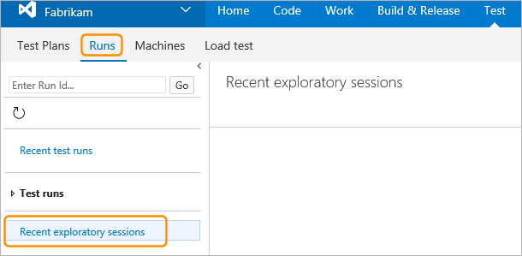
7. Now see how you can [view your sessions and get insights](https://www.visualstudio.com/en-us/docs/test/manual-exploratory-testing/insights-exploratory-testing).